Guide to Rippling’s integration with Employee Navigator
Rippling has partnered with Employee Navigator (EN), a third-party benefits administration system, to offer you seamless management of your third-party benefits directly within Rippling. This is a 360-degree integration, meaning data will sync between both systems:
- Rippling sends demographic and compensation data to Employee Navigator for qualification and enrollments.
- Employee Navigator sends contribution and deduction data to Rippling for payroll.

Setup steps
- Step 1: Request the integration within the EN system
  - Go to your Payroll tab in Employee Navigator +add integration Choose ‘Rippling’ from the dropdown.
  - When this is completed, Rippling will be notified that you have requested the integration.

- Step 2: Install the Employee Navigator app in Rippling
  - Once you’ve completed the required steps within your EN account, install the Employee Navigator app in Rippling by following the steps below:
- In your Rippling admin account, open the Rippling App Shop.
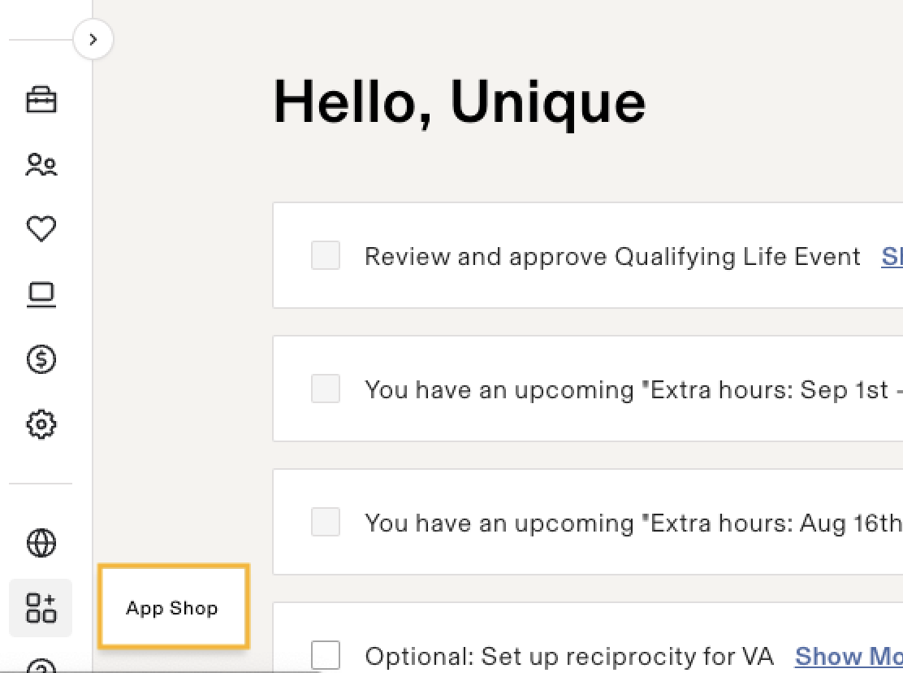
- Search ‘Employee Navigator’ in the search bar or click this link.
- Click Request Integration if you don’t already have an account with EN or Connect account if you’re an existing account holder.
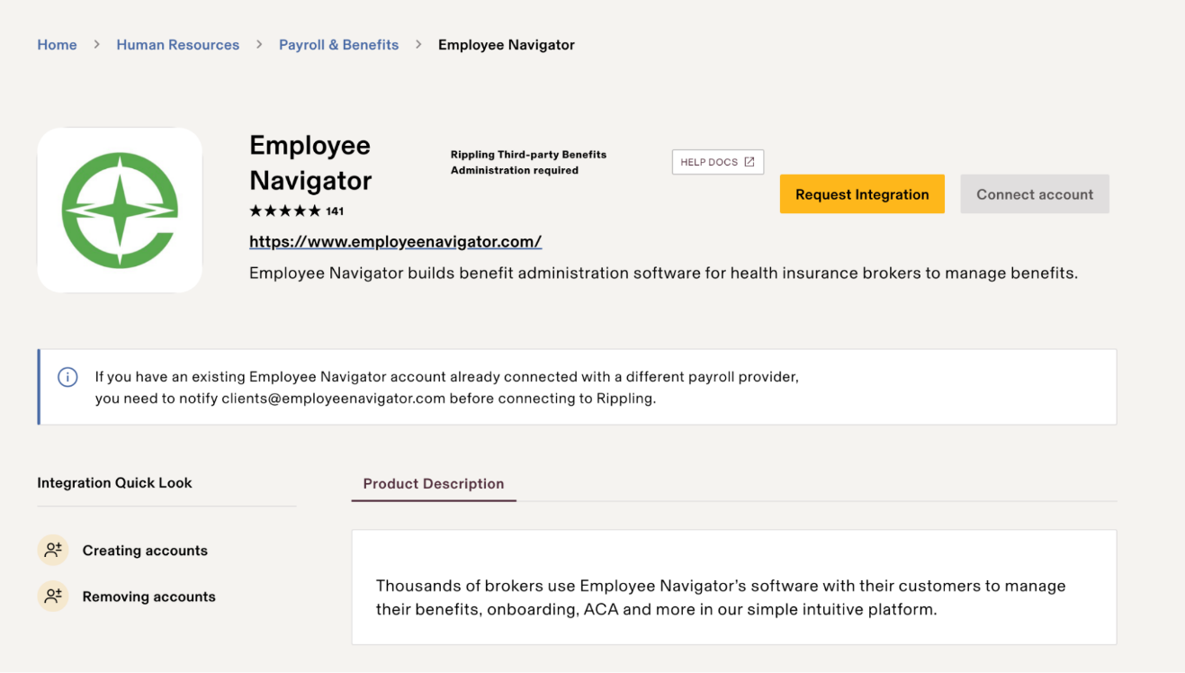
- Follow the steps to complete the Employee Navigator app installation in Rippling.

- Step 3: Find and map your Rippling deduction codes into Employee Navigator
- Go to this link: https://app.rippling.com/payroll/dashboard/deductions
- Find and map the applicable ‘Deduction Name’ values into Employee Navigator
  - Examples of what you might see
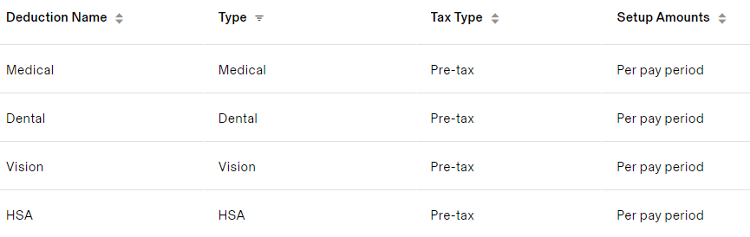

- Step 4: Schedule and complete the initial implementation call with EN Support to learn how to complete the mandatory audits.
  - Before this call with EN: Within your Employee Navigator app in Rippling, go to the Reports tab and pull the Demographic audit and Deduction audit reports
  - 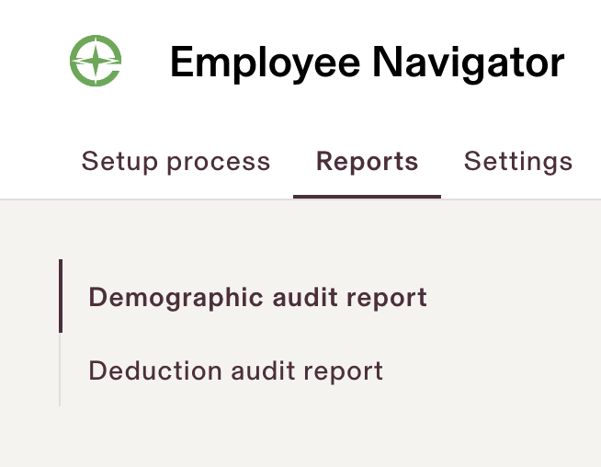

- Step 5: Go live
  - Once you’ve completed parts 1-4 and have had any related review calls, your EN analyst will provide notice when the integration is ready to go live.
  - Rippling will confirm via email that the API connection and notifications have been enabled.
Tip: As you move through the setup process, return to Rippling to mark the implementation tasks complete to ensure the integration can go live in your account.
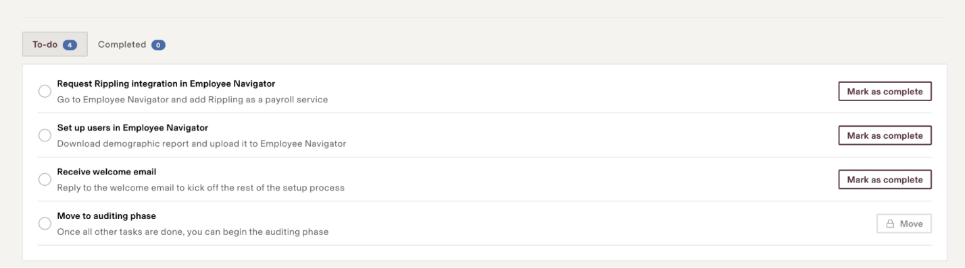
See below for a list of fields that will be exchanged:
Rippling Field Name | Direction of Exchange
Payroll ID | Rippling to EN - only
Employee Social Security Number (SSN) | Rippling to EN - only
First Name | Rippling to EN - only
Middle Name | Rippling to EN - only
Last Name | Rippling to EN - only
Date of Birth | Rippling to EN - only
Hire Date | Rippling to EN - only
Termination Date | Rippling to EN - only
Salary Effective Date | Rippling to EN - only
Compensation Basis | Rippling to EN - only
Annual Salary | Rippling to EN - only
Hourly Rate | Rippling to EN - only
Address 1 | Rippling to EN - only
Address 2 | Rippling to EN - only
City | Rippling to EN - only
State | Rippling to EN - only
ZIP | Rippling to EN - only
Work Email | Rippling to EN - only
Personal Email | Rippling to EN - only
Email | Rippling to EN - only
Pay Period Deduction | EN to Rippling - only
Deduction Amount | EN to Rippling - only

